Download IDE netbeans, jdk, javascript, Python, visual Studio code, visual paradigm

JDK (Java Development Kit)

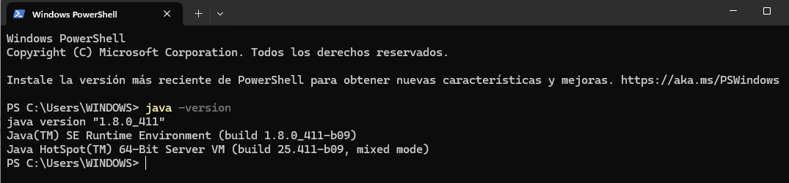

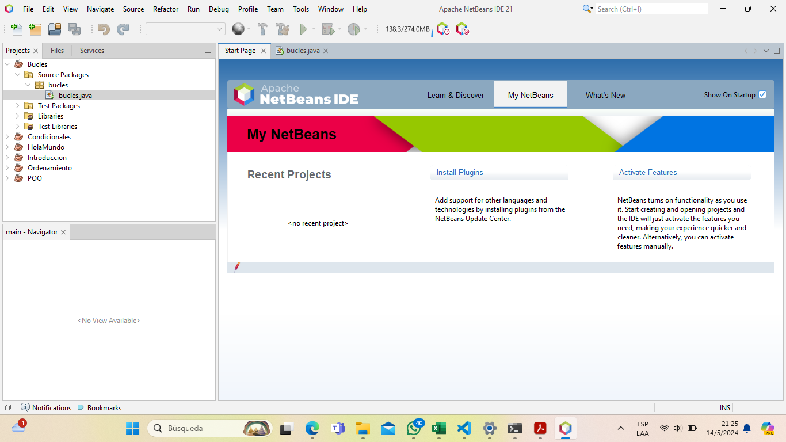IDE netbeans

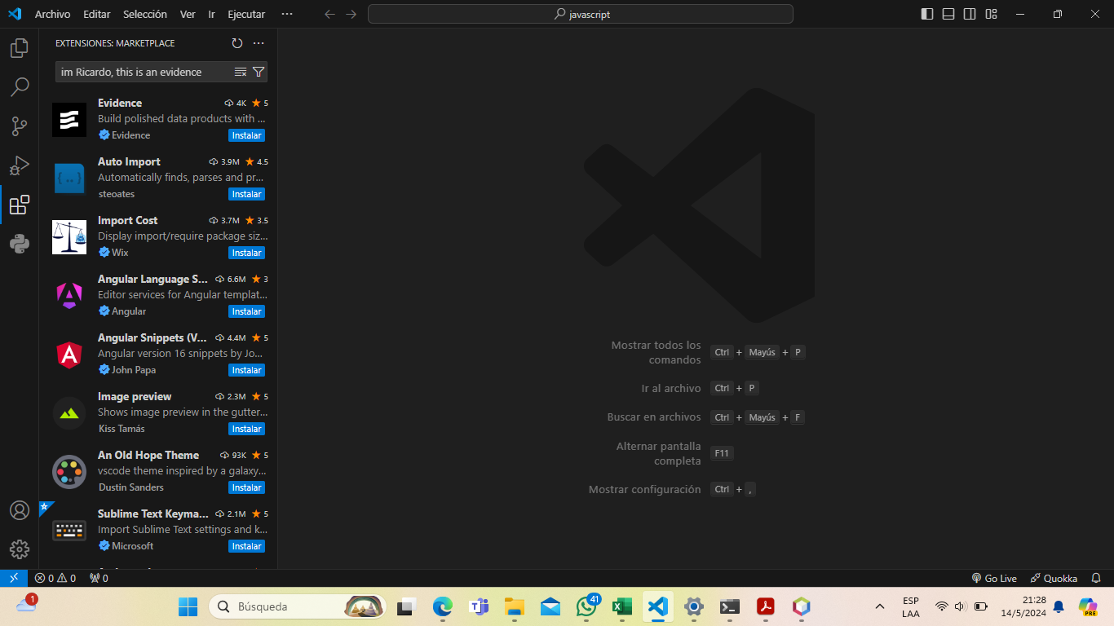Visual Studio Code

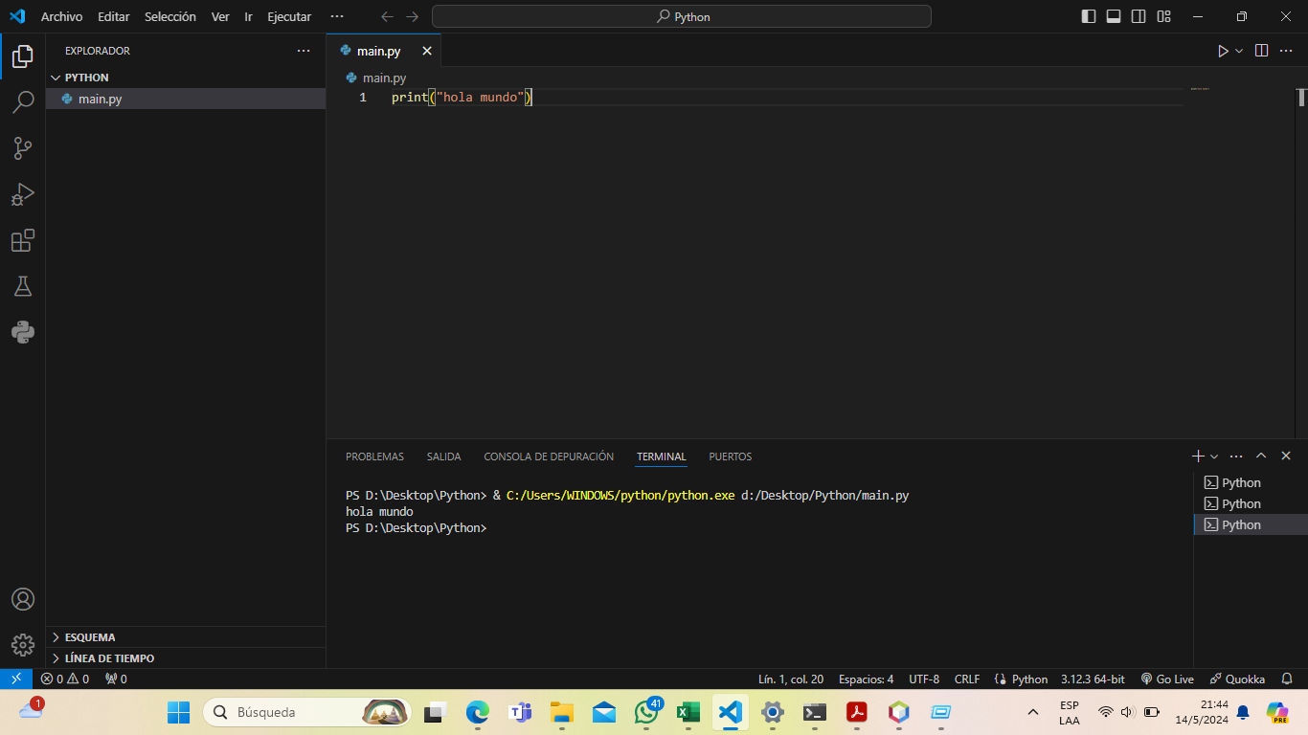Python

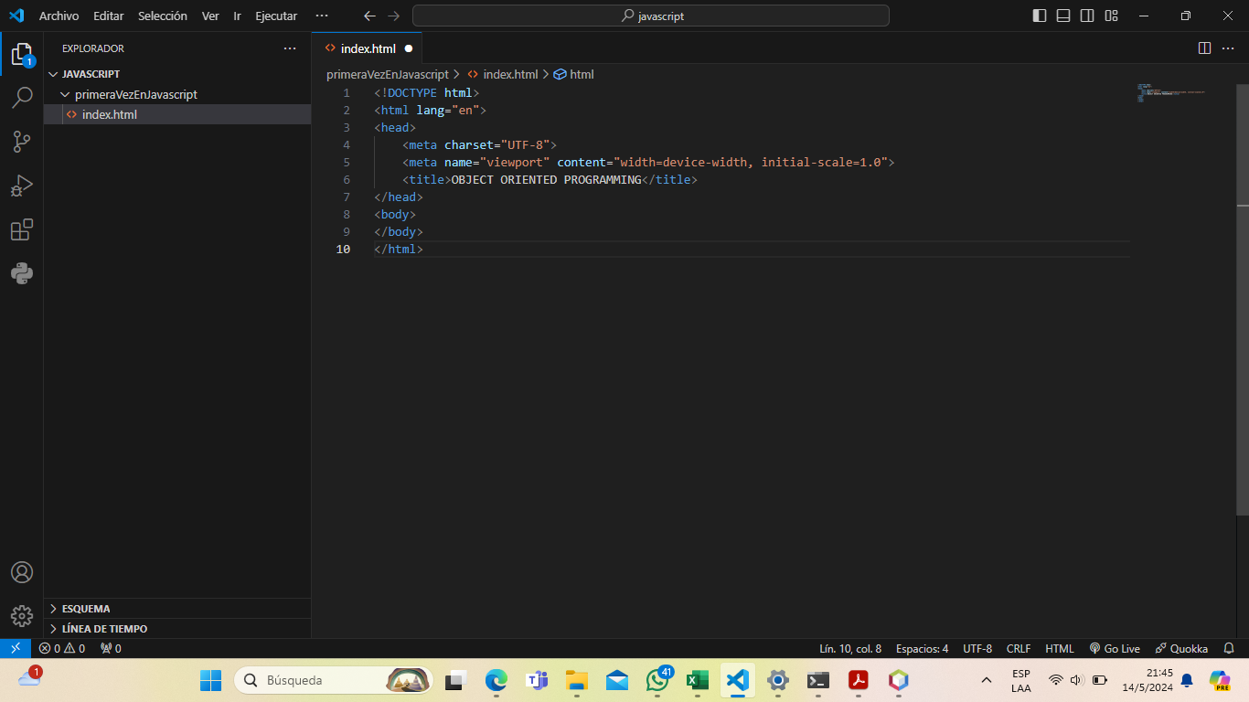JavaScript

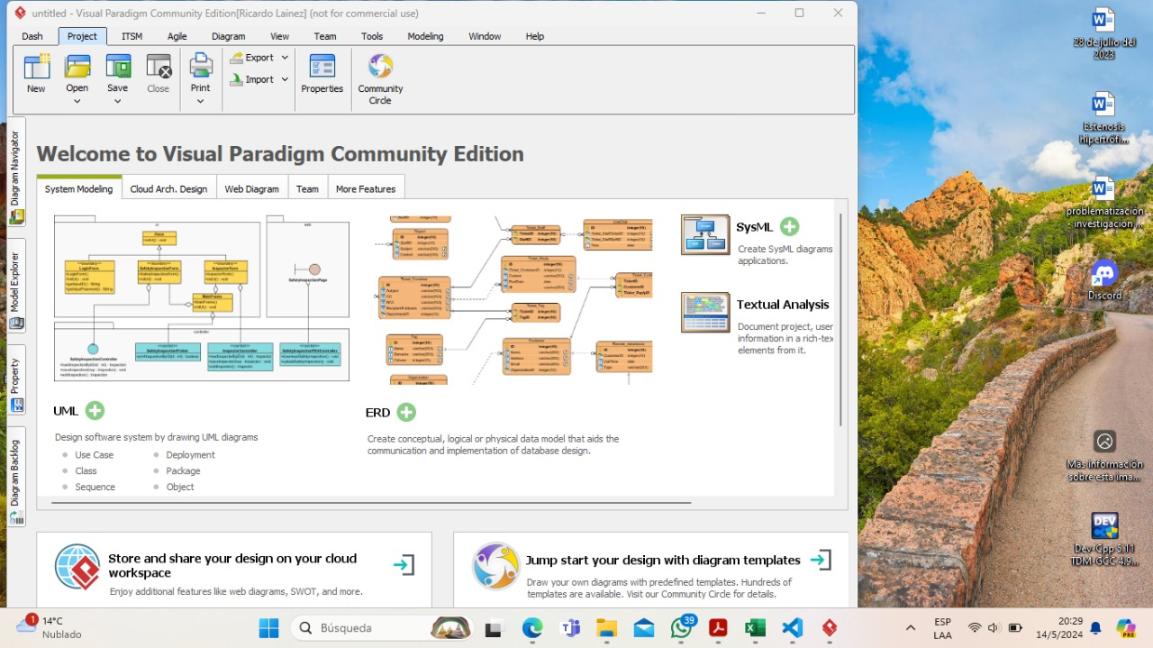Visual paradigm (Community Edition)